FOREST HILLS BAPTIST CHURCH
LABOR DAY WEEKEND AT FORT CASWELL 2023
www.fortcaswell.com
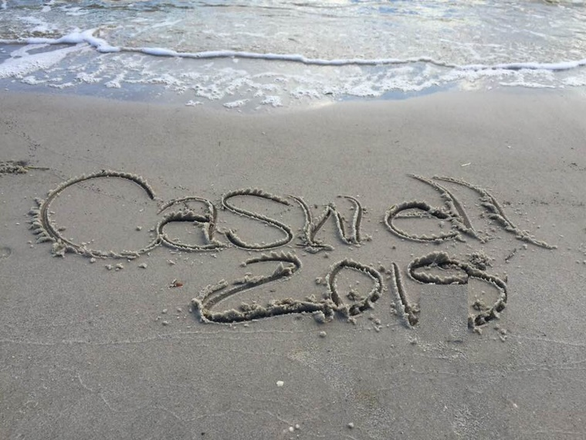
-------------------------------------------------------------------------------------
Welcome to Caswell ’23.
BACKGROUND
This will be the 26th time for this special weekend event at this special place.
In no particular order, here is information you need to know for our weekend at Fort Caswell.
1. WHERE WE WILL BE STAYING / EATING / WORSHIPING
Here is a map of the campus:
http://fortcaswell.com/wp-content/uploads/2018/01/Large-Map-New-Logo.pdf
HEADQUARTERS. Meals will be in the Chapel Annex.
LODGING. Note that rooms are assigned, generally speaking, based on the order that deposits are received and also based on the number of nights folks are staying. (Checkout on Sunday is 10 AM - BEFORE WORSHIP and those cottages will need to be available for the Caswell staff to turn over at that time.)
Accommodations are basic, but quite comfortable. No TVs, alarm clocks, hair dryers, irons. There is wi-fi. Probably soap, but please bring all other toiletries.
CABINS 13-14 are Seashell and Sand Dune. These rooms have double beds and most have a bunk bed. In the cabins we bring all our own linens – the beds have pillows. Cabins have a full kitchen with a refrigerator and coffee maker which will be used to story community food.
“HOTELS” 7-30-10 are Fort Casawell, Oleander, nd Oceana. These rooms have 1 or 2 double beds and linens are included. Some folks like to bring their own fluffy bath towels anyway. There may be a shared kitchen in Oceana.
WORSHIP. We plan to use the Chapel for worship on Saturday night and Sunday morning.
2. The Schedule
Friday – Travel from Raleigh. Dinner is on your own.
Arrive at North Carolina Baptist Assembly - 100 Caswell Beach Road, Oak Island, NC and pick up your room keys. Typically quite a few folks arrive after dark. No problem.
Saturday Morning - Breakfast – details to follow
Saturday morning / Saturday afternoon - Free Time. Walking / biking / beach / tennis / fishing / visiting. Free time. The kids really enjoy having bicycles to explore the campus.
Saturday Lunch – Bag lunch Sandwiches - floating. Eat in or take your sandwich to the beach.
The swimming pool is usually open in the afternoon for a couple of hours (1-3 or 2-4)
Saturday Dinner – Pizza and salad. In the Chapel Annex. 6 PM
Saturday - Session #1 - 7-9 PM in the Chapel. Bring your Bible.
Games, cards and socializing.
Sunday morning -Breakfast- Pancakes- 8-9:00 AM in THE CHAPEL ANNEX.
Sunday worship - In the Chapel. 9:30-11:30. Bring Bible.
GROUP PICTURE FOLLOWING WORSHIP.
Sunday lunch – Bag Lunch / Sandwiches
Sunday dinner - On your own.
Monday - continental breakfast. 8 - 9
Monday Checkout is 10 AM. Hopefully we will still have access to the Chapel Annex a bit longer.
3. WHAT TO BRING
a. Bible
b. Bath Towels as needed and Beach Towels
c. Bath soap / shampoo (not provided)
d. Sun screen / bug spray
e. Recreation equipment - bikes, tennis, beach, etc.
f. Your own drinks for non-meal times
g. Your own snacks for non-meal times
h. Bed Linens as needed for CABINS- Double Sheets for double beds. Twin sheets or sleeping bag for bunks. Pillow case.
4. RECREATION
BIKES. If you or your kids enjoy bikes, it is a great place. A lot of our kids take bikes.
TENNIS. There is one tennis court. In recent years we have had a fair amount of success in having regular access to the court (although we must share if there are others wanting to play)
WATER. Caswell is uniquely located where the Cape Fear river meets the Atlantic Ocean. There is a pier for fishing. Even a dock for boats. And the beach.....
BEACH. Access to the beach is on campus, but you have to bike or drive there (if you are lugging stuff). Beach access is labeled #47 on the map. Weather permitting, the beach is the primary destination on Saturday, Sunday afternoon, and Monday. Lunches are sandwiches and can be made "to go" to take to the beach. Bring your own beach stuff - chairs, umbrella, toys, etc.
PUTT PUTT - there is a mini-golf course is open for a couple of hours each afternoon.
GYM. There is a gym for basketball that is usually open.
POOL. The pool is typically open for 2 hours on Saturday and Sunday afternoon (1-3 or 2-4)
Bring your own drinks for non-meal time. Sand Dune and Sea Shell have full size refrigerators. Please don't put all your drinks in at once and best to label them.
If you want ice for your beach cooler, you can put some in the chest freezers. We will have coolers of “church ice” for lunches and Saturday dinner and maybe some available for community use.
6. CASWELL RULES Please share the following campus rules with your family: https://fortcaswell.com/policies-services/

